Communication Between Linkage Server and OHS

Away exchange sends an inbound ‘s’ orders to the Linkage Server through the OLA Hub. The linkage Server checks for if OHS is enable and sends linkage ‘s’ orders to the OHS. The OHS receives the linkage order and routes it to the PAR workstation through the PAR Adapter based on the class level routing parameters setting. OHS also passes the inbound S order time to live to PAR. The following sequence diagram describes the flow of an inbound linkage S order :

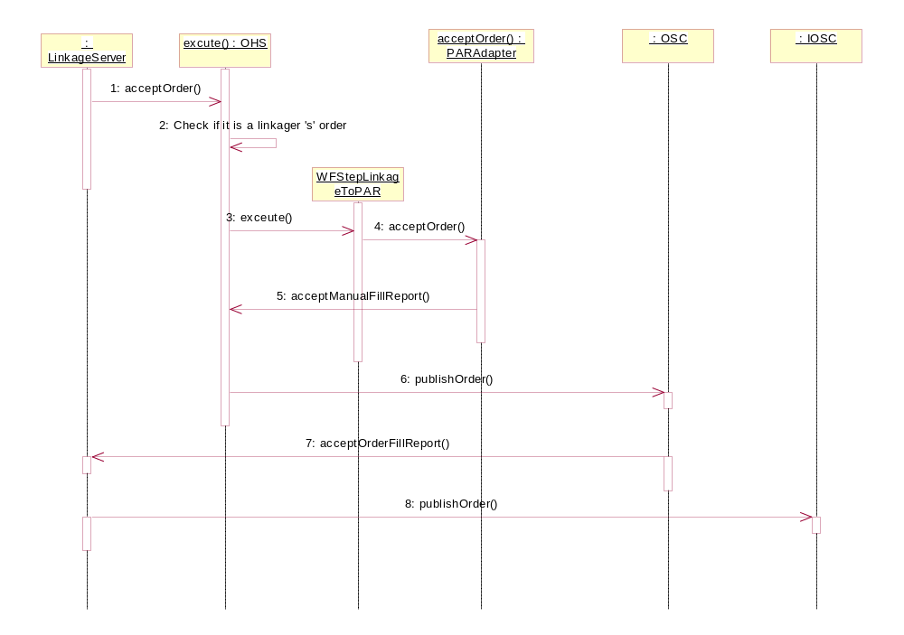

There is a LinkageInboundWorkflow.xml file created and does the following steps.

- Check the session for the inbound linkage order;
- Set the order to ACTIVE;
- Generate new ORSID for the order;
- Append CBOE market data and NBBO;
- Check if the order is inbound linkage S order;
- Send to PAR.

There will be a new class WFStepLinkageSOrderToPAR for sending the inbound linkage S order to PAR which inherits from an existing class WFStepSendToPAR. A new method getRoutingDestination() will add to the existing class and the new class overrides the method to provide the new SessionClass based routing key. The idea is to reuse existing functionality as below.

public class WFStepSendToPAR extends WFStepNamedRoute
{
public Enum execute(OrderContext p_context) throws Exception
{
Destination dest = getRoutingDestination(p_context);

…..
}

protected Destination getRoutingDestination(OrderContext p_context)
{
RoutingKey key = RoutingPropertyKeyHelper.buildDirectDestinationParKey(p_context.getSession(), p_context.getOrder().getOrderId().executingOrGiveUpFirm.exchange, p_context.getOrder().getOrderId().executingOrGiveUpFirm.firmNumber, p_context.getOrder().getOrderId().correspondentFirm, p_context.getRouteId().charAt(0));
return routingPropertySrvc.getDirectRoutingPAR(key);
}

public class WFStepLinkageSOrderToPAR extends WFStepSendToPAR
{

protected Destination getRoutingDestination(OrderContext p_context)
{
RoutingKey key = RoutingPropertyKeyHelper.buildLinkageOrderToParKey(p_context.getSession(),p_context.getOrder().getClassKey());
return routingPropertySrvc.getLinkageOrderToParDestination(key);
}
}

